Software Requirements Specification

for

Unified Academic & Student Calendar System
Version 1.0 approved
Prepared by Group 18
LUT University
<date created>
Revision History iii
1. Introduction 1
1.1. Purpose 1
1.2. Document Conventions 1
1.3. Intended Audience and Reading Suggestions 1
1.4. Product Scope 2
1.5. References 2
2. Overall Description 3
2.1. Product Perspective 3
2.2. Product Functions 3
2.3. User Classes and Characteristics 3
2.4. Operating Environment 4
2.5. Design and Implementation Constraints 4
2.6. User Documentation 4
2.7. Assumptions and Dependencies 4
3. System Features 4
3.1. Unified View (MF1) 5
3.2. Academic Events View (MF2) 5
3.3. Social Events Web Scraper Bot (MF3) 6
3.4. Personal Events (MF4) 6
3.5. Manual Event Creation (MF5) 7
3.6. Push notifications (MF5) 7
3.7. Export & Synchronization (MF7) 8
3.8. Login Integration (MF8) 8
3.9. Public API (MF9) 9
3.10. Language Selection (MF10) 9
4. External Interface Requirements 10
4.1. User Interfaces 10
4.2. Other Interfaces 11
5. Other Nonfunctional Requirements 11
5.1. Performance Requirements 12
5.2. Security Requirements 14
5.3. Software Quality Attributes 14
5.4. Business Rules 15
6. Other Requirements 16
7. Declaration of AI use 17
Appendix A: Figma UI Snapshots 18
A.1 Login View 18
A.2 Search View 19
A.3 Search Results View 20
A.4 Calendar View 21
A.5 Task List View 22
A.6 Create Event View 23
Appendix B: Glossary 24
Appendix C: Analysis Models 24
Appendix D: To Be Determined List 25

Revision History
Name | Date | Reason For Changes | Version
Group 18 | 09.10.2026 | Initial draft | 0.1
Group 18 | 09.10.2026 |  | 0.2

Introduction

Purpose
This SRS describes the software requirement for the Unified Academic & Student Calendar System (UASCS), a web application that combines LUT lecture schedules, assignment deadlines, student events and personal events into one calendar view. It is prepared by Group 18 for the client, Group 20.

Document Conventions
Priority
Each requirement is assigned a priority based on the MoSCoW framework (Must, Should, Could, Won’t) and a status according to the Requirements Management Plan.

Unique identifiers
All unique identifiers (BO1 - BO6, MF1 - MF9, L01 - L03) refer to items defined in the Vision and Scope Document [2].

Intended Audience and Reading Suggestions
The readers are the roles defined in the Requirement Management Plan Document, Section 2.1. All readers should start with Section 1 and Section 2 for an overview of the product.

Reader | Description
Project Manager (PM) | Manages scope, priorities, and versions and ensures that features meet the agreements made with the client.
Requirements Engineering Team (RET) | Ensures that the requirements adhere to the agreement with the client.
Requirements Analyst (RA) | Documents and maintains the requirements and ensures they are verifiable, feasible, and clear.
Design & Development Team (DDT) | Designs and develops the system using the requirements.
Testing Engineers (TE) | Tests the system against the requirements (both functional and non-functional).
Unified Academic & Student Calendar System (UASCS) Stakeholders | Review the document and provide your comments on the requirements and change requests.

Product Scope
The background, business objectives, vision, release scope, and limitations are described in the Vision and Scope Document and are not repeated here.

References
No. | Document | Author | Version | Date
[1] | Vision and Scope Document | Group 18 | v1.1 | 12.10.2026
[2] | Requirements Management Plan | Group 18 | v0.2 | 09.10.2026
[3] | Use Case Document | Group 18 | v0.1 | 13.10.2026
[4] | Sustainability Analysis of Requirements | Group 18 | v0.2 | 09.10.2026
[5] | Sisu API [link] | Funidata Oy | v1.8+ | Accessed 16.10.2026
[6] | Moodle API [link] | Moodle HQ | v3.3+ | Accessed 16.10.2026
[7] | TimeEdit API [link] | TimeEdit AB | v1.0+ | Accessed 16.10.2026
[8] | Telegram API [link] | Telegram FZ-LLC | v3.0+ | Accessed 16.10.2026

Overall Description

Product Perspective
Unified Academic & Student Calendar System (UASCS) is a new, standalone web application, and it does not replace any existing LUT systems, as it reads data from them and shows everything in one calendar. The stakeholders are shown in the context diagram in the Vision and Scope Document.

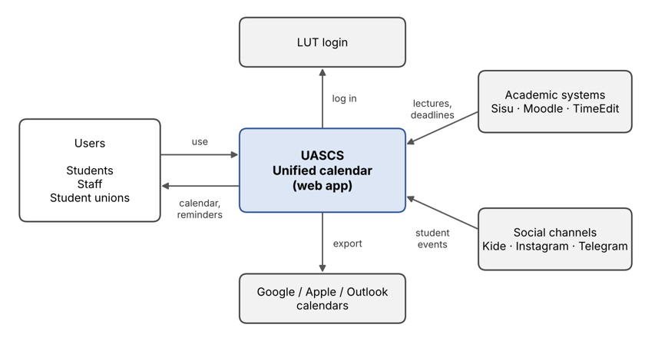
Figure 1. UASCS and the systems it connects to

Product Functions
The main functions are the major features in the Vision and Scope Document, section 2.2. The details are given in Section 4.
Feature | Release
MF1 Unified View - all events in one calendar | 1
MF2 Academic Events View - data from Sisu, Moodle and TimeEdit | 1
MF7 Export & Synchronization - to Google, Apple or Outlook calendars | 1
MF8 Login Integration - log in with an LUT account | 1
MF3 Social Events Web Scraper - events from Kide, Instagram and Telegram | 2
MF4 Personal Events - private personal events | 2
MF5 Manual Event Creation - privileged users create events | 2
MF6 Push Notifications - reminders of events and deadlines | 2
MF9 Public API - for external developers | 3

User Classes and Characteristics
The user classes are based on the stakeholder profiles in the Vision and Scope Document, Section 4.1. Students are the most important user class.

User Class | Description
Students | Lectures, deadlines and events viewing and creation of personal events.
Teaching staff | Schedules viewing. The course information is extracted from the current system.
Student unions and event organizers | The events are automatically collected. The event creation is also possible.
LUT IT Services | System hosting and maintenance.

Operating Environment
UASCS is a web application that works fully responsive and automatically adjusts to look great on any standard phone, tablet, or desktop screen. It is hosted on LUT IT servers and it is running 99%. More details are in the Vision and Scope Document, Section 4.3.

Design and Implementation Constraints
- Users log in with their LUT account only.
- The source of academic information includes APIs of Sisu, Moodle, and TimeEdit. In case of any conflict, TimeEdit will be used
- Notifications will be provided through the app’s push application alone, not through emails.
- Budget allocation would be around €200,000, with the maximum limit being €500,000.

All other constraints and limitations (L01 to L03) are listed in the Vision and Scope Document, Sections 3.3 and 4.

User Documentation
User manual for application, administrator manual for LUT IT services, and API documentation for developers (Release 3).

Assumptions and Dependencies
The assumptions and dependencies are listed in the Vision and Scope Document Section 2.3. The primary assumption is that Sisu, Moodle, and TimeEdit keep providing stable APIs.

System Features
This section outlines functional requirements of the Unified Academic & Student Calendar System, categorized by Major Feature. Requirement attributes are defined in the Requirements Management Plan [2]. Error conditions and expected behavior are specified in related use cases in the Use Case Document [3].

Unified View (MF1)
The Unified View feature displays event data, course schedules, and assignment deadlines from multiple sources in a single, integrated view. See UC-2, UC-3 and UC-10 in the Use Case Document [3].

Req ID | Origin | Priority | Version | Owner | Status
FR1 | MF1 | Must | 1.0 | PM | Under Review
Description
The system shall display event data received from MF2, MF3, MF4, and MF5 on a calendar grid, rendering individual items as distinct, color-coded block elements.

Acceptance criteria
Visual inspection and user acceptance on the UI elements.
FR2 | MF1 | Must | 1.0 | DDT | Under Review
Description
The system shall display event data received from MF2, MF3, MF4, and MF5 as a list sorted chronologically.

Acceptance criteria
Visual inspection and user acceptance on the UI elements.

Academic Events View (MF2)
The Academic Events View feature automatically connects with external academic platforms (Sisu, Moodle, TimeEdit) via their respective APIs to retrieve course schedules and assignment deadlines data. See UC-4 in the Use Case Document [3].

Req ID | Origin | Priority | Version | Owner | Status
FR3 | MF2 | Must | 1.0 | DDT | Under Review
Description
The system shall fetch student course schedules from Sisu, assignment deadlines from Moodle, and room bookings from TimeEdit.

Acceptance criteria
Automated integration testing that data is successfully retrieved from Sisu, Moodle and TimeEdit.

Comments
Combined into a single requirement because all three external services share the same data request module.
FR4 | MF2 | Must | 1.0 | TE | Under Review
Description
The system shall automatically trigger updates to synchronize data from Sisu, Moodle, and TimeEdit at scheduled intervals.

Acceptance criteria
Automated unit tests for scheduled synchronization. Monitoring tools.

Social Events Web Scraper Bot (MF3)
The Social Events Web Scraper Bot feature automatically extracts event details, dates, and location data from target online platforms via web scraping scripts. See UC-6 in the Use Case Document [3].

Req ID | Origin | Priority | Version | Owner | Status
FR5 | MF3 | Should | 1.1 | DDT | Proposed
Description
The system shall automatically scrape, parse, and convert raw event data into standard records containing public event titles, dates, locations, and descriptions from target online platforms.

Acceptance criteria
Automated integration tests and manual validation of the quality of scraped web data.

Comments
Combined into a single requirement because it refers to a singular system module.

Personal Events (MF4)
The Personal Events feature enables users to customize their private schedule by creating, editing, categorizing, and configuring notifications for personal events. See UC-7 in the Use Case Document [3].

Req ID | Origin | Priority | Version | Owner | Status
FR6 | MF4 | Should | 1.1 | DDT | Proposed
Description
The system shall allow users to create, edit, categorize, and configure notifications for personal events within their private schedule.

Acceptance criteria
Unit tests, visual inspection, and user acceptance of the personal events feature.

Manual Event Creation (MF5)
The Manual Event Creation feature enables privileged users to manually create events and assign specific target audiences for distribution within the unified view. See UC-11 in the Use Case Document [3].

Req ID | Origin | Priority | Version | Owner | Status
FR7 | MF5 | Could | 1.1 | PM | Proposed
Description
The system shall allow authorized users to manually create events with a selecting target audience.

Acceptance criteria
Unit tests, visual inspection, and user acceptance of the manual event creation feature.

Push notifications (MF5)
The Push Notifications feature delivers customizable, scheduled browser alerts for upcoming events in the unified view. See UC-8 in the Use Case Document [3].

Req ID | Origin | Priority | Version | Owner | Status
FR8 | MF6 | Should | 1.1 | DDT | Proposed
Description
The system shall allow users to set up notifications.

Acceptance criteria
Unit tests and user acceptance of the notifications feature.
FR9 | MF6 | Should | 1.1 | TE | Proposed
Description
The system shall automatically send scheduled web page notifications at the designated time.

Acceptance criteria
Simulated time triggers that the system successfully delivers notifications.

Export & Synchronization (MF7)
The Export & Synchronization feature allows users to export and synchronize their unified schedule with external calendar tools such as Google Calendar, Apple Calendar, and Microsoft Outlook. See UC-5 in the Use Case Document [3].

Req ID | Origin | Priority | Version | Owner | Status
FR10 | MF7 | Must | 1.0 | DDT | Under Review
Description
The system shall allow users to export their unified schedule as an iCalendar (.ics) file for import into external calendar applications.

Acceptance criteria
Functional testing of the exported .ics file.
FR11 | MF7 | Must | 1.0 | TE | Under Review
Description
The system shall synchronize changes from the unified schedule to connected external calendar accounts at scheduled intervals.

Acceptance criteria
Integration tests of the synchronization feature.

Login Integration (MF8)
The Login Integration feature users to log in directly with their existing personal university account without requiring any additional registration steps. See UC-1 in the Use Case Document [3].

Req ID | Origin | Priority | Version | Owner | Status
FR12 | MF8 | Must | 1.0 | RET | Under Review
Description
The system shall authenticate users using their personal university credentials via Single Sign-On (SSO) protocols without requiring separate account creation.

Acceptance criteria
Functional testing of the SSO authentication.

Public API (MF9)
The Public API feature provides a secure programmatic interface that enables external developers to connect with and query the unified view event data. See UC-9 in the Use Case Document [3].

Req ID | Origin | Priority | Version | Owner | Status
FR13 | MF9 | Could | 1.1 | RA | Proposed
Description
The system shall provide a documented public API that allows authenticated external developers to securely query and retrieve system event data.

Acceptance criteria
Integration and authentication tests.

Language Selection (MF10)
The Language Selection feature lets users change the language of the user interface. See UC-12 in the Use Case Document [3]. See UC-12 in the Use Case Document [3].

Req ID | Origin | Priority | Version | Owner | Status
FR14 | MF10 | Should | 1.1 | DDT | Proposed
Description
The system shall allow users to switch the language of the user interface (menus and view titles) between English, Finnish and Swedish. If a label is missing in the selected language, the Finnish label shall be shown.

Acceptance criteria
Functional testing of the language switch in all three languages and inspection of the fallback labels.

External Interface Requirements

User Interfaces
Responsiveness
The user interface will be developed primarily for desktop web browsers, with a responsive layout designed to support standard screen formats. Dedicated mobile design is scheduled for implementation during the third system release.

Branding
The UASCS System shall strictly follow the official branding guidelines of the main LUT University website. The main color palette shall consist of black (#000000) and vibrant green (#1fa800).

Layout
Each screen shall maintain a consistent layout architecture, including:
- a top navigation bar with relevant buttons
- a standardized LUT University footer
- uniform error messages

A visual example is shown in Figure 2.

Localization
The user interface shall support English and Finnish as the primary languages, with architecture in place to support additional languages in future releases. See FR14.

Visual References
Additional static snapshots of a UI prototype are provided in Appendix A:
- A.1 Login Screen View
- A.2 Search View
- A.3 Search Results View
- A.4 Calendar View
- A.5 Task List View
- A.6 Create Event View

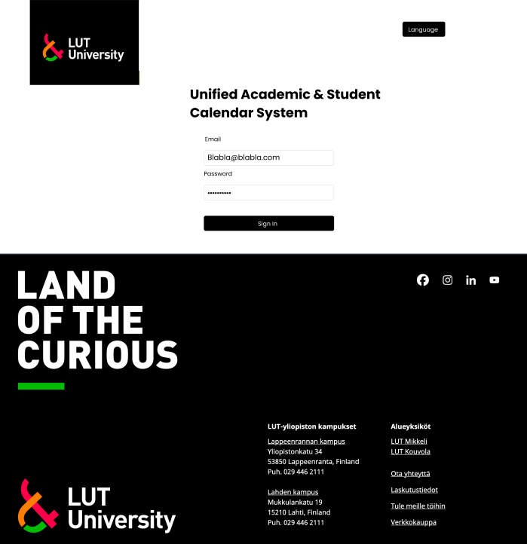
Figure 2. The login page - a visual example of branding and layout.

Other Interfaces
Software and hardware
The system operates as a standard client-server web application, with a mobile application planned for the third release. Client devices do not require specialized hardware components (e.g. camera, GPS) for standard operation.

Communication and data management
As detailed in Section 2.4, the server-side infrastructure is hosted on LUT IT servers. Communication is based on secure HTTPS protocols using JSON for data exchange, while event data and log histories are stored in a database. The selection of technologies, programming languages, and database systems is determined by DDT.

External APIs
The system shall be integrated with the following external APIs:
- Sisu [4]
- Moodle [5]
- TimeEdit [6]
- Telegram [7]

Additionally:
- FR5 relies on access to Instagram and Kide, neither of which provides an official API. Therefore, DDT must build custom functionality to fully satisfy FR5.
- FR12 determines the system must support SSO integration with LUT University systems.

Other Nonfunctional Requirements

Performance Requirements
Req ID | Origin | Priority | Version | Owner | Status
NFR1 | MF1 | Must | 1.0 | PM | Proposed
Description
Must synced in real-time with the external calendar sources. The maximum acceptable delay is 5 minutes.

Acceptance criteria
API and content update inspection and threshold acceptance of the delay.
NFR2 | MF2 | Must | 1.0 | PM | Proposed
Description
Must synced in real-time with the external calendar sources. The maximum acceptable delay is 5 minutes.

Acceptance criteria
API and content update inspection and threshold acceptance of the delay.
NFR3 | MF3 | Must | 1.0 | PM | Proposed
Description
Must synced in real-time with the external calendar sources. The maximum acceptable delay is 5 minutes.

Acceptance criteria
API and content update inspection and threshold acceptance of the delay.
NFR4 | MF4 | Must | 1.0 | PM | Proposed
Description
Must synced in real-time with the external calendar sources. The maximum acceptable delay is 5 minutes.

Acceptance criteria
API and content update inspection and threshold acceptance of the delay.
NFR5 | MF5 | Must | 1.0 | PM | Proposed
Description
Manually created public events must be displayed to users in under 500ms after being published.

Acceptance criteria
API and content update inspection and threshold acceptance of the delay.
NFR6 | MF7 | Must | 1.0 | PM | Proposed
Description
Exporting the view to .ics must be done in under 10 second.

Acceptance criteria
Format inspection and threshold acceptance on the delay.
NFR7 | MF9 | Must | 1.0 | PM | Proposed
Description
API response times must be under 500ms.

Acceptance criteria
Threshold acceptance of the delay.

Security Requirements
The UASCS application will be hosted on LUT servers and utilizes the databases provided by LUT’s IT department. Moreover, the system requires valid LUT accounts for access, hence, it benefits from the pre-existing LUT IT department’s protocols and security practices. However, it is important to explicitly define the security requirements of personal events and public APIs provided by the system.

Req ID | Origin | Priority | Version | Owner | Status
NFR8 | MF4 | Must | 1.0 | RA | Under Review
Description
Personal events must be bound to the user’s account and must neither be accessible nor viewable by unauthorized users.

Acceptance criteria
Permissions and authorization testing.
NFR9 | MF9 | Could | 1.1 | RA | Proposed
Description
Public APIs must strictly only share data related to public events that are not used for internal identification. Internal IDs must be kept secret. Moreover, provided APIs must only accept GET headers over HTTPS requests and not allow update, insert, or delete operations.

Acceptance criteria
API response body and operations inspection.

Software Quality Attributes
Req ID | Origin | Priority | Version | Owner | Status
NFR10 | - | Must | 1.0 | PM | Under Review
Description
The system must maintain high portability by ensuring responsiveness across all desktop, laptop, tablet, and mobile phone screen sizes.

Acceptance criteria
Visual inspection and user acceptance on the UI elements.
NFR11 | - | Must | 1.0 | PM | Under Review
Description
The system must maintain availability with a maximum of 48 hours of down time per year.

Acceptance criteria
Load simulation testing, maintenance schedule inspection, and downtime tracking.
NFR12 | - | Must | 1.0 | TE | Proposed
Description
The system must maintain correctness and reliability by being synced with external calendar sources. The sync delay is defined in NFR1.

Acceptance criteria
API and content update inspection and threshold acceptance of the delay.
NFR13 | - | Should | 1.1 | TE | Proposed
Description
The system must maintain correctness by scoring a 95% format conversion accuracy when importing from calendars that do not use the .ics format.

Acceptance criteria
Format conversion inspection and user acceptance on the UI elements.
NFR14 | - | Could | 1.1 | DDT | Proposed
Description
The system must maintain reusability by providing secure HTTPS GET public APIs for Academic and Social events.

Acceptance criteria
API response body and operations inspection.
NFR15 | - | Should | 1.1 | DDT | Proposed
Description
The must maintain 100% test coverage in the project’s GitHub repository.

Acceptance criteria
A 100% test coverage score for each merge request is required before approving a merge.

Business Rules
Req ID | Origin | Priority | Version | Owner | Status
NFR16 | - | Could | 1.1 | RA | Proposed
Description
Only users with elevated “organizer” roles must have the ability to create, update, or remove a manual public event.

Acceptance criteria
Permissions and authorization testing.
NFR17 | - | Could | 1.1 | RA | Proposed
Description
When academic schedule data from different sources conflict, the data from TimeEdit is the source of truth.

Acceptance criteria
Content inspection and simulated testing.
NFR18 | - | Must | 1.0 | PM | Proposed
Description
Only users with a valid LUT account can access the system.

Acceptance criteria
Permissions and authorization testing.
NFR19 | - | Must | 1.0 | RA | Proposed
Description
Personal events are visible only to the user who created them and cannot be shared.

Acceptance criteria
Permissions and authorization testing.
NFR20 | - | Must | 1.0 | RA | Proposed
Description
Notifications are sent only within the application, never by email.

Acceptance criteria
Notification delivery testing.

Other Requirements
Req ID | Origin | Priority | Version | Owner | Status
NFR21 | - | Must | 1.0 | DDT | Proposed
Description
The database must use separate tables for each event type: Academic, Social, and Personal.

Acceptance criteria
Database schema inspection.
NFR22 | - | Could | 1.1 | RA | Proposed
Description
Manually created public events can only be of type Academic or Social.

Acceptance criteria
Type testing and content inspection.
NFR23 | - | Must | 1.0 | PM | Under Review
Description
Management of user login sessions must be in accordance with LUT protocols and security regulations.

Acceptance criteria
Regulations adherence testing and evaluation.

Declaration of AI use
For that assignment, ChatGPT (https://chatgpt.com/) was used for supplementary reading and research, and the same LLM was also utilized for linguistic purposes to enhance text readability.

Appendix A: Figma UI Snapshots

A.1 Login View

A.2 Search View
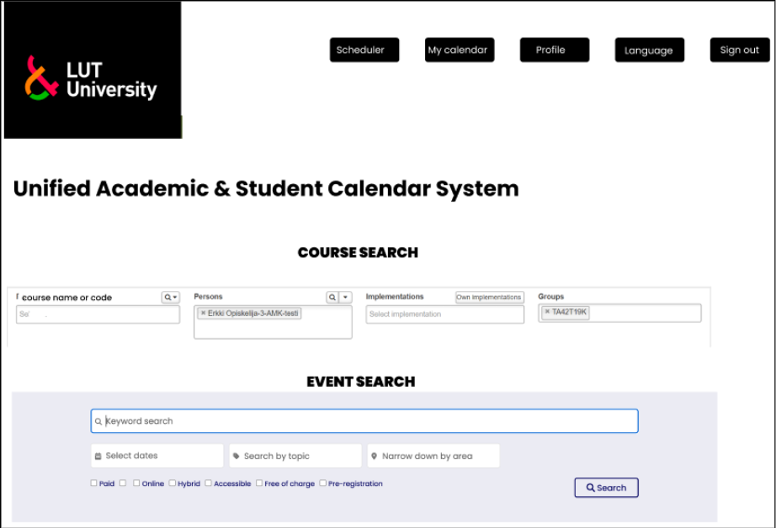

A.3 Search Results View
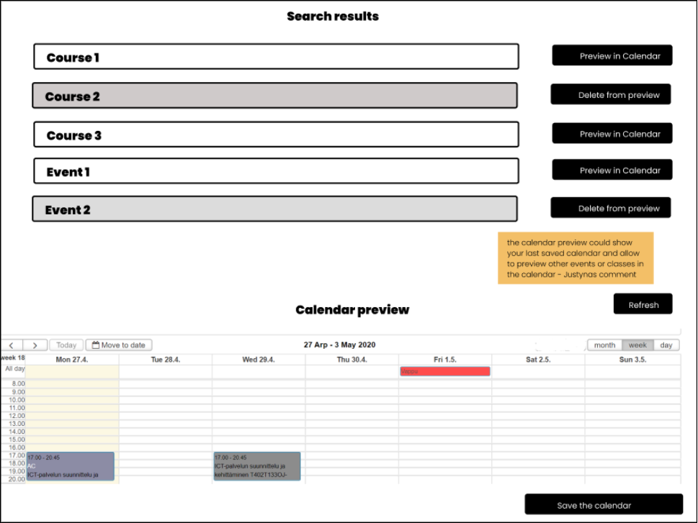

A.4 Calendar View
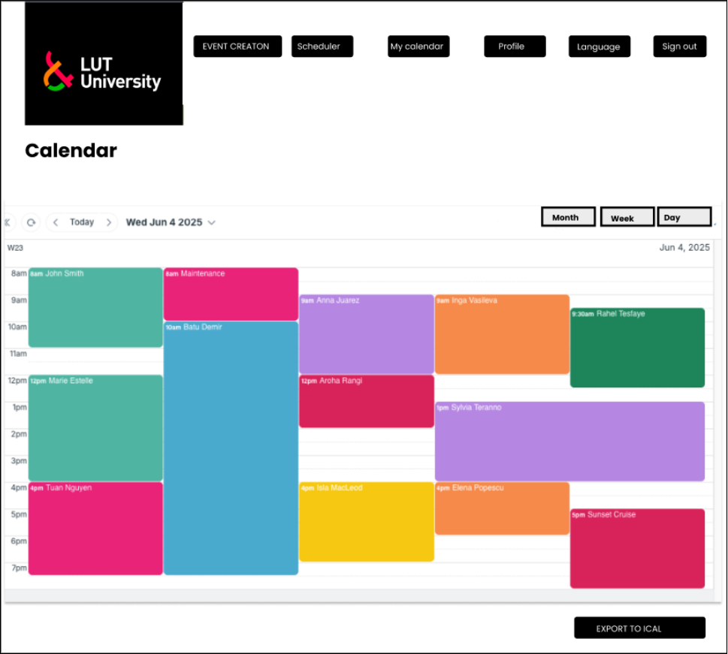

A.5 Task List View
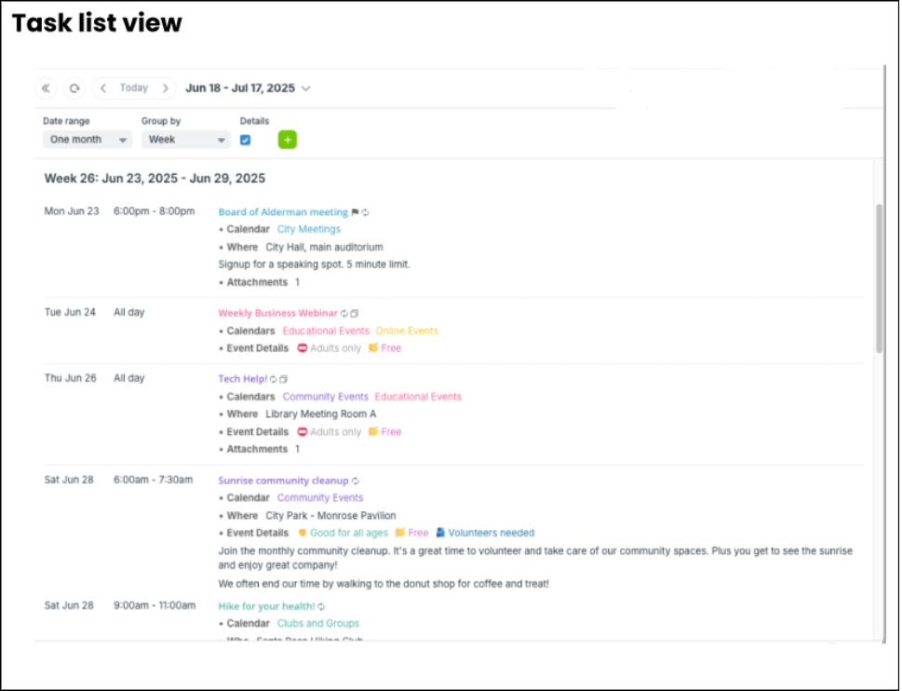

A.6 Create Event View
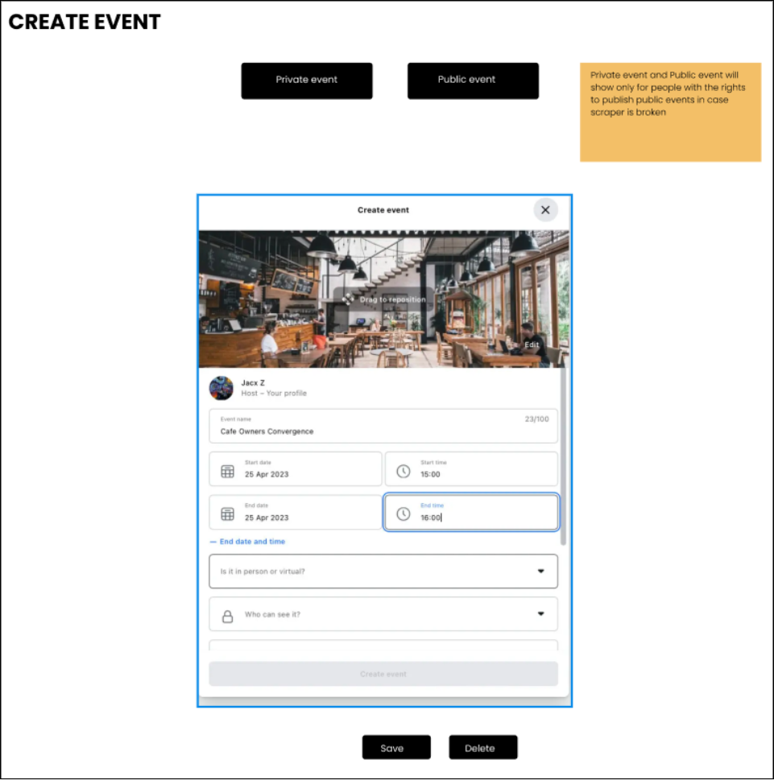

Appendix B: Glossary
Terms used in this SRS. Requirements management terms are defined in the Requirement Management Plans [2], Appendix B.
Term | Definition
API | Application Programming Interface. A way for software systems to exchange data.
BO | Business Objective, defined in the Vision and Scope Document [1].
FR / NFR | Functional requirement / Non-functional requirement.
.ics (iCalendar) | Standard calendar file format supported by Google Calendar, Apple Calendar and Outlook.
Kide | Platform used by student unions to publish events and sell tickets.
MF | Major Feature, defined in the Vision and Scope Document [1].
Moodle | LUT learning platform with course material and assignment deadlines.
MoSCoW | Prioritisation method: Must, Should, Could, Won’t have.
Sisu | LUT student information system for study plans and course enrolments.
SSO | Single Sign-On. Logging in once with the LUT account.
TimeEdit | LUT scheduling system for lectures and rooms.
UASCS | Unified Academic & Student Calendar System, the product specified in this SRS.
UC | Use case, defined in the Use Case Document [3].
Unified view | One calendar view that combines academic, social and personal events.

Appendix C: Analysis Models
The analysis models for UASCS are in the other project documents and are not repeated here
Model | Location
Problem tree and goal tree | Vision and Scope Document [1], Appendix 1 and 2
Context diagram | Vision and Scope Document [1], Figure 1
System context (systems UASCS connects to) | This SRS, Figure 1 (Section 2.1)
Use case diagram | Use Case Document [3]
Goal model (sustainability) | Sustainability Analysis of Requirements [4], Figure 1
MF | Major Feature, defined in the Vision and Scope Document [1].

Appendix D: To Be Determined List
The following items are still open:
No. | Item | Section
TBD-1 | Exact sync interval for scheduled updates (FR-MF2-2, FR-MF7-2). | 3.2, 3.7
TBD-2 | How events from Instagram and Kide are collected, since they have no official public API. | 4.2
TBD-3 | No use case defined yet for Manual Event Creation (MF5). | 3.5

